**Module 1**

**Fundamental**

**What is SDLC?**

SDLC stands for Software Development Life Cycle.That is used to verifying the test basis via the test design.

**What is Software Testing?**

Software testing is the process to identify the completeness, correctness and quality of developed software.

**What is Agile Methodology?**

The Agile Model believes that every project needs to be handled differently.

**What is SRS?**

SRS stands for Software Requirement Specification.SRS is a complete description of the behavior of the system to be developed.

**What is Oops?**

Oops is a concept that developers use for binding data and function using the concept of class and object.

**Write basic concepts of oops.**

1.Class

2.Object

3.Abstraction

4.Inheritance

5.Polymorphism

6.Encapsulation

**What is an Object?**

Any entity that has its own state and behavior.

**What is Class?**

Collection of objects is called class.

**What is Encapsulation?**

Binding of data is called Encapsulation.

**What is Inheritance?**

When one object acquires all the properties and behavior of the parent class is called Inheritance.

**What is Polymorphism?**

Many ways to perform anything is called Polymorphism.

**Draw use case on Online Book Shopping.**

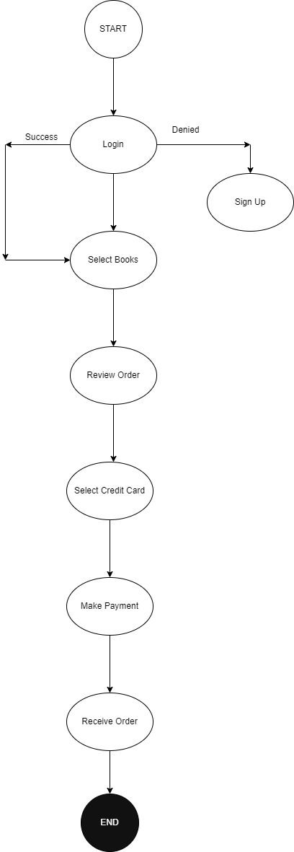

**Draw use case on online bill payment system(paytm).**

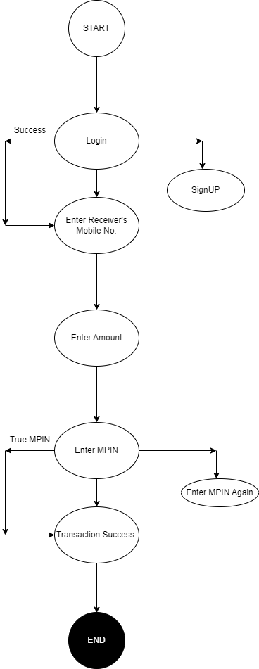

**Write SDLC phases with basic introduction.**

There are a total Six phases of SDLC.

1.Requirement Gathering:-

Establish customer needs

2.Analysis:-

Analysis represents the what phase.

3.Design:-

Design represents the why phase.

4.Implementation:-

Construct a solution for software.

5.Testing:-

Validate the solution against the requirements.

6.Maintenance:-

Repair defects and adapt the solution for new requirements.

**Explain phases of the waterfall model.**

The Waterfall Model has mainly six phases.

1.Requirement Gathering:-

Establish customer needs

2.Analysis:-

Analysis represents the what phase.

3.Design:-

Design represents the why phase.

4.Implementation:-

Construct a solution for software.

5.Testing:-

Validate the solution against the requirements.

6.Maintenance:-

Repair defects and adapt the solution for new requirements.

**Write the phases of the Spiral Model.**

The Spiral Model has mainly Six phases.

1.Planning:-

Determination of objectives, alternatives and constraints.

2.Risk Analysis:-

Analysis of alternatives and identification/ resolution of risks.

3.Go No-Go Decision:-

First Prototype.

4.Engineering:-

Development of the next level product.

5.Customer Evaluation:-

Assessment of the engineering result.

6.Completion:-

Alpha Demo.

**Write agile manifesto principles.**

**Explain the working methodology of the agile model and also write pros and cons.**

The Agile model breaks the product into small incremental builds.

Each build is provided in iterations.

Each iteration typically lasts from about one to three weeks.

pros:-

promotes teamwork and cross training.

suitable for fixing or changing requirements.

little or no planning required.

gives flexibility to developers.

Cons:-

Not suitable for complex solutions.

More risk of sustainability, maintainability and extensibility.

Depends heavily on customer interaction.

**Draw use case on Online shopping product using COD.**

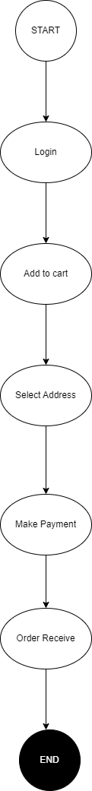

**Draw use case on Online shopping product using payment gateway**

